WRITING CHEMICAL FORMULAE

Knowledge of the valency of ions allows us to write formulae to represent different chemicals.

“RULES”
1. Write down the ions involved and look at the valency of each.

2. If the numbers are the same, take one of each ion.

3. If the numbers are different, cross the numbers down to
the bottom of each ion.

Examples

magnesium oxide

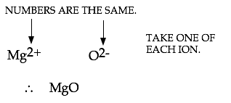
barium chloride

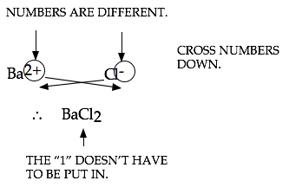

magnesium phosphate

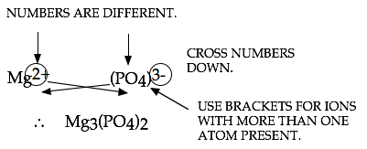

Note

The table of ions will be given to you for use in tests and exams - just know how to use them!

